Characteristic មាន១២

Simple

|  |
| --- |
| Java មានលក្ខណៈធម្មតាព្រោះ |
| syntax ពឹងផ្អែកលើ រឺ ស្រដៀងទៅនឹង C++ (ងាយស្រួលក្នុងការរៀនបើសិនបន្ទាប់ពីចេះ C++). |
| កាត់ចេញនូវ ភាពភាន់ច្រឡំ​ និង features ដែលមិនត្រូវការដូចជា explicit pointers, operator overloading -ល-។ |
| មិនចាំបាច់កាត់ចេញនូច unreferenced objects វា automatic Garbage Collection in java. |

### Object-oriented

|  |
| --- |
| Object-oriented means we organize our software as a combination of different types of objects that incorporates both data and behavior. |
| Object-oriented programming (OOPs) is a methodology that simplify software development and maintenance by providing some rules. |
| Basic concepts of OOPs are: |
| 1. Object 2. Class 3. Inheritance 4. Polymorphism 5. Abstraction 6. Encapsulation |

java is platform independentPlatform Independent

A platform is the hardware or software environment in which a program runs.

There are two types of platforms software-based and hardware-based. Java provides software-based platform.

The Java platform differs from most other platforms in the sense that it is a software-based platform that runs on the top of other hardware-based platforms. It has two components:

1. Runtime Environment
2. API(Application Programming Interface)

Java code can be run on multiple platforms e.g. Windows, Linux, Sun Solaris, Mac/OS etc. Java code is compiled by the compiler and converted into bytecode. This bytecode is a platform-independent code because it can be run on multiple platforms i.e. Write Once and Run Anywhere(WORA).

Secured

Java is secured because:

* **No explicit pointer**
* **Java Programs run inside virtual machine sandbox**

how java is secured

* **Classloader:** adds security by separating the package for the classes of the local file system from those that are imported from network sources.
* **Bytecode Verifier:** checks the code fragments for illegal code that can violate access right to objects.
* **Security Manager:** determines what resources a class can access such as reading and writing to the local disk.

These security are provided by java language. Some security can also be provided by application developer through SSL, JAAS, Cryptography etc.

Robust

Robust simply means strong. Java uses strong memory management. There are lack of pointers that avoids security problem. There is automatic garbage collection in java. There is exception handling and type checking mechanism in java. All these points makes java robust.

Architecture-neutral

There is no implementation dependent features e.g. size of primitive types is fixed.

In C programming, int data type occupies 2 bytes of memory for 32-bit architecture and 4 bytes of memory for 64-bit architecture. But in java, it occupies 4 bytes of memory for both 32 and 64 bit architectures.

Portable

We may carry the java bytecode to any platform.

High-performance

|  |
| --- |
| Java is faster than traditional interpretation since byte code is "close" to native code still somewhat slower than a compiled language (e.g., C++) |

Distributed

|  |
| --- |
| We can create distributed applications in java. RMI and EJB are used for creating distributed applications. We may access files by calling the methods from any machine on the internet. |

Multi-threaded

A thread is like a separate program, executing concurrently. We can write Java programs that deal with many tasks at once by defining multiple threads. The main advantage of multi-threading is that it doesn't occupy memory for each thread. It shares a common memory area. Threads are important for multi-media, Web applications etc.

### JRE

JRE is an acronym for Java Runtime Environment.It is used to provide runtime environment.It is the implementation of JVM. It physically exists. It contains set of libraries + other files that JVM uses at runtime.

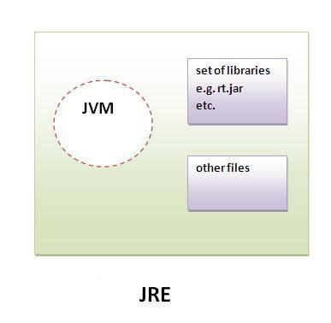Implementation of JVMs are also actively released by other companies besides Sun Micro Systems.

JDK

JDK is an acronym for Java Development Kit.It physically exists.It contains JRE + development tools.